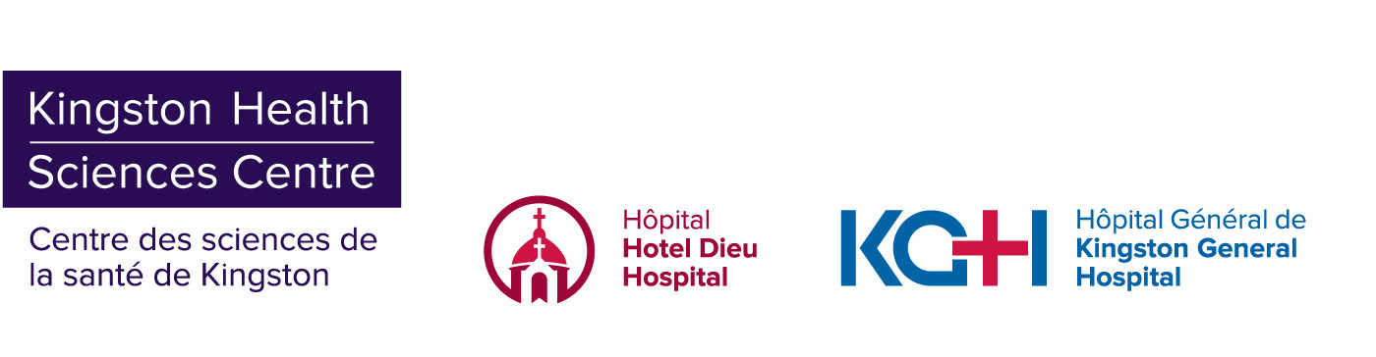

**INFORMATION BULLETIN**

**Temporary COVID-19 Assessment Centre will open at St. Lawrence College on Sunday June 28**

**Kingston, ON – June 26, 2020 –** In response to the high demand for COVID-19 testing following the recent community outbreak, a Temporary COVID-19 Assessment Centre will operate in the parking lot at St. Lawrence College on Sunday June 28, 2020 from 9 a.m. to 2 p.m.

We request that only those who were clients at the Binh’s Nail Salon, close contacts of someone who has tested positive, or those who are symptomatic attend the testing centre at St. Lawrence College on Sunday. This allows us to prioritize those who are at the highest risk of infection. If you were not a client of Binh’s or have not been in close contact with someone who was, please consider waiting until the Leon’s Centre Assessment Centre opens on Monday, June 29 to be tested.

All patients who present to an Assessment Centre for testing should be wearing a mask and practicing physical distancing.

**Where to get tested in Kingston this weekend**

* Saturday June 27: Memorial Centre, 303 York St.
  + Open 9 a.m. to 2 p.m.
* Sunday June 28: St. Lawrence College parking lot, 100 Portsmouth Ave.
  + Open 9 a.m. to 2 p.m.
  + Priority will be given to clients of Binh’s Nail Salon, close contacts of someone who has tested positive, and anyone who is symptomatic.
* Monday June 29: Leon’s Centre, 1 Tragically Hip Way (Enter at Gate 2 on Ontario St)
  + Open 7 days a week, 9 a.m. to 4 p.m.

For the most current information on COVID-19 visit [**www.Kflaph.ca/Coronavirus**](http://www.kflaph.ca/Coronavirus) or [**www.Ontario.ca/coronavirus**](http://www.ontario.ca/coronavirus).

**Media Contact:**

Maclaine Clark | 613-583-7705

[maclaine.clark@kingstonhsc.ca](mailto:maclaine.clark@kingstonhsc.ca)