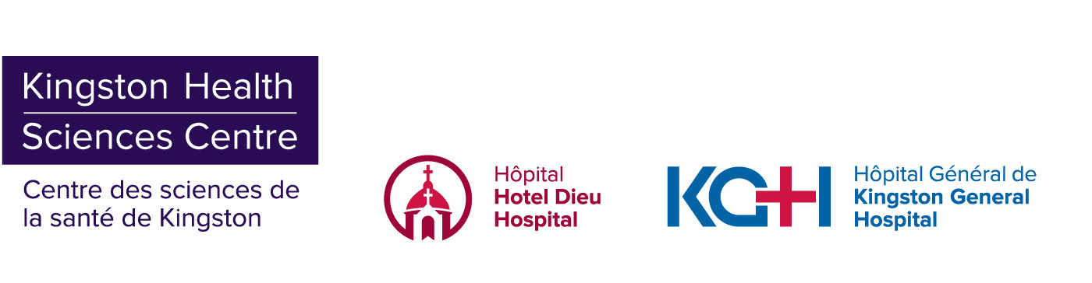

**INFORMATION BULLETIN**

**Temporary COVID-19 Assessment Centre at St. Lawrence College on Canada Day, July 1**

**Kingston, ON – June 30, 2020 –** In order to continue to meet the current demand for testing, the Temporary COVID-19 Assessment Centre will be re-opened in the parking lot at St. Lawrence College this Canada Day, Wednesday July 1 from 9 a.m. to 12 p.m.

This Temporary Assessment Centre will be open for walk-up and drive-through testing. Patients should enter off Portsmouth Avenue.

Please note that the COVID-19 Assessment Centre at the Leon’s Centre will be closed on Wednesday July 1.

We request that only those who were clients of a salon or commercial establishment where there has been an outbreak, close contacts of someone who has tested positive, or those who are symptomatic attend the testing centre at St. Lawrence College. This allows us to prioritize those who are at the highest risk of infection. If you were not a client of one of the affected nail salons, or have not been in close contact with someone who was, please consider waiting until the Leon’s Centre Assessment Centre re-opens on Thursday July 2.

All patients who present to an Assessment Centre for testing should be wearing a mask and practicing physical distancing. Please remember to bring your health card.

For the most current information on COVID-19 visit [**www.Kflaph.ca/Coronavirus**](http://www.kflaph.ca/Coronavirus) or [**www.Ontario.ca/coronavirus**](http://www.ontario.ca/coronavirus).

**Media Contact:**

Maclaine Clark | 613-583-7705

[maclaine.clark@kingstonhsc.ca](mailto:maclaine.clark@kingstonhsc.ca)