# Corporate Visitor Access Application Guidance

Our role caring for people from across the region is vital and our collective efforts contribute to the safest possible environment for all.  As such,KHSC’s facilities remain under temporary restrictions to ensure the safety of our vulnerable patients and our staff.  We are still controlling access carefully.

In an effort to support this relationship and ensure patient and staff safety in the work place, KHSC has a vendor monitoring system1 in place that must be adhered to by **Corporate Visitors** (as defined below).

**Corporate Visitor**: A Corporate Visitor can be a vendor, supplier, consultant, or anyone who provides goods or services to the hospital. This includes, but is not limited to, consultants for pharmaceuticals and hospitality services, working visitors, temp agency staff, non-construction/non-maintenance contractors and those providing product or equipment in-service education sessions or demonstrations for products/equipment that are currently used or will be used in the future by the hospital.

*To determine if a Corporate Visitor Access Application is required, use the following table as guidance:*

**Corporate Visitor Access Application Form Requirements**

|  |  |  |  |  |  |
| --- | --- | --- | --- | --- | --- |
| **Visitor Type** | **Urgent?** | **New or Repeat (same person, same purpose)** | **Access Application Required** | **Guidance** | |
| Corporate | Yes | New | Yes | Submit a Visitor Access Application Form for new Corporate Visitors for their first visit, or for their **first visit** for a **new person/purpose.** | |
| Repeat | No | If the **same Visitor** has previously been approved for access previously for the **same purpose**, no new application is required. | |
| Corporate | No |  | | | Reschedule or accomplish virtually |
| Patient/Staff | **Use Patient Visitor screening** | | | | |

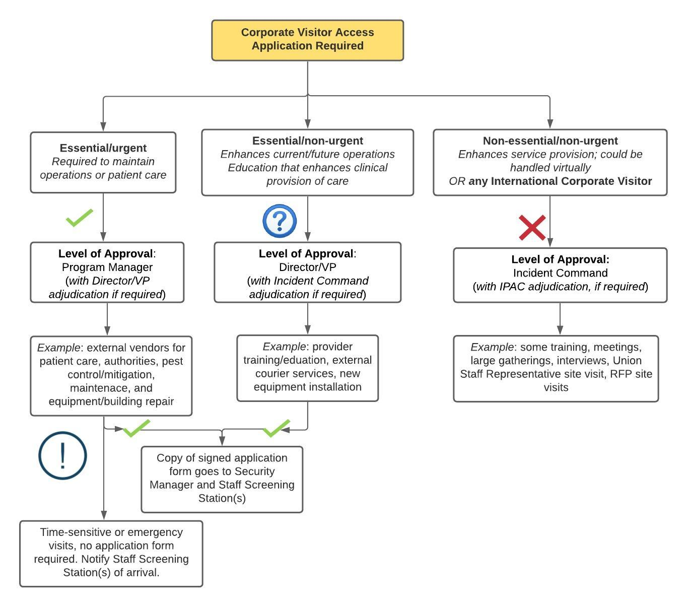***To determine where, and to whom, to submit the completed Corporate Visitor Access***

***Application Form, please follow the process below:***

|  |  |  |  |  |  |
| --- | --- | --- | --- | --- | --- |
| Visitor Company: |  | | | | |
| Visitor Representative: |  | | | | |
| Visitor Representative Location: | O KFL&A | O Outside KFL&A | | O Outside ON | O Outside Canada* |
| If outside KFL&A, city: |  | | | | |
| * Application form applicable only to those under exemption to the [Quarantine Act](https://laws-lois.justice.gc.ca/eng/acts/Q-1.1/index.html); Pursuant to paragraph 6(e) of the Minimizing the Risk of Exposure to COVID-19 in Canada Order (Mandatory Isolation), No. 5, issued pursuant to section 58 of the [Quarantine Act](https://laws-lois.justice.gc.ca/eng/acts/Q-1.1/index.html), the Chief Public Health Officer may determine a class of persons who provide an essential service while in Canada  ***ANY VISITOR APPLICATION FOR A VISITOR ARRIVING FROM OUTSIDE CANADA MUST GO TO INCIDENT COMMAND*** | | | | | |
| MRP**: |  | | | | |
| **MRP is the individual(s) requesting access for the Corporate Visitor(s) and the individual(s) responsible for the Application Form submission as well as supervision for the duration of the visit. Please reference the [Guidelines for Safe Gatherings](https://khscnow.kingstonhsc.ca/document/14946). | | | | | |
| Visit Department/ Area: |  | | | | |
| Visit Site: | O KGH | | O HDH | | |
| Date(s)/Time: | Start: | | End: | | |
| Describe any patient interaction required if applicable: |  | | | | |

|  |  |  |  |
| --- | --- | --- | --- |
| Access Application Triage | | | |
| Visit Timing | O Urgent | O Not Urgent | |
| Describe the Visit activity in detail and reason for urgent request. *Please note that incomplete or inadequate details will result in a delay in approval.* |  | | |
| Have other alternatives been explored (e.g., virtual)? | O Yes | | O No |
| Describe: | | |

## All Corporate Visitors must read and agree to comply with the following guidelines:

*Prior to visit*

1. Visitor(s) should not be coming to KHSC unless they have a pre-scheduled appointment with a MRP from KHSC.
2. In order for the Visitor(s) to be granted access to KHSC the MRP must coordinate using the directions above to provide a copy of the *Corporate Visitor* *Access Application Form* to KGHRI (Lisa McAvoy) who will arrange to have it sent to Staff Screening Station(s) prior to arrival via email.
3. Visitor(s) should review the *Health and Safety Training for Employees and Affiliates* and familiarize themselves with the requirements for their visit.
4. Protection services will prepare visitors identification for the Visitor(s). For visits less than 1 week duration, a Temporary ID badge will be assigned. For visits greater than 1 week or repeated visits, a Photo ID badge will be provided. Please note that for repeated visits, an additional Access Application will be required if the Visitor or purpose for visit is different.

*Upon arrival*

1. All Visitor(s), presenting to the hospital, at the pre-arranged time that has been approved by their KHSC MRP are required to sign in and out at security. This is where they will receive an identification badge that must be worn at chest level at all times and returned to security when the Visitor signs out at the end of their visit.
2. Visitor(s) will review and sign off on the ‘Hospital Health & Safety Requirements for Affiliates’ ([**Appendix B**](https://khscnow.kingstonhsc.ca/policy/1639)) prior to starting work at the location. The signed form will be maintained by that facility using the log provided ([**Appendix C**](https://khscnow.kingstonhsc.ca/policy/1639)).
3. Visitor(s) must evaluate themselves prior to arriving for illness and pass all screening questions2 eachday of their visit. If they are ill or symptomatic, they must exclude themselves or delay the work.
4. All Visitor(s) are to perform hand hygiene upon arrival, and when leaving our building, and any time they touch their mask.

*For the duration of visit*

1. Visitor(s) must comply with universal masking at all times while in our facilities.
2. Visitor(s) must be met at one of the staff entrances by the MRP who is overseeing the work, and escorted at all times while in our facilities.
3. Movement must be limited to only the area where they are working – Visitor(s) are not to access the cafeteria or any other area of the hospital.
4. An attendance log must be maintained by the MRP including details of any patient interaction, if applicable, for contact tracing purposes. The MRP must also record interactions with other KHSC employees if the interactions are greater than 15 minutes duration, within 6 feet.

*For KHSC employees*

1. Any KHSC staff/physicians/volunteer and/or learner who has concerns dealing with a Corporate Visitor who has not complied with this policy should report their concerns to Security personnel. The KHSC Director of Protection Services, in consultation with the MRP, and 3SO Senior Manager Strategic Sourcing and Procurement, will communicate with the Organization regarding the non-compliance with this policy and/or behavior in question and will determine the future access privileges.

**MRP AND SIGNING AUTHORITY ACKNOWLEDGMENT**

I/we have read, understood, and agree to comply with the terms of this agreement and applicable policies1 in my/our capacity as MRP.

|  |  |  |  |
| --- | --- | --- | --- |
| **MRP Name:** | **__________________** | **Signing Authority:** | **__________________** |
| **Signature:** | **__________________** | **Signature:** | **__________________** |
| **Title:** | **__________________** | **Title:** | **__________________** |
| **Date:** | **__________________** | **Date:** | **__________________** |