**Primary Care Management Pathway**

**Parkinson’s Disease**

**Background**

Primary care management pathways are being developed by specialist and primary care groups to support the management of common, non-urgent conditions for which long wait times to specialty care currently exist. The pathways will help identify patients with high-risk features and facilitate early or timely referral to specialists as needed.

A primary care management pathway has been developed for Parkinson’s Disease by neurologists and primary care physicians as there are currently long wait times to be seen by a neurologist and there are also ways that primary care physicians can support patients with new or suspected Parkinson’s Disease prior to needing to make a referral.

**Defining condition**

Parkinson’s disease can be described as a chronic and progressive neurodegenerative brain disorder that progresses slowly in most people, and is characterized by bradykinesia, tremor and rigidity in its early course with a good response to levodopa.

**Patient information**

It is possible that your patient and/or their family member may express a desire for additional information about the primary care management pathway and their role or experience throughout the process of being on a pathway. Additional information for patient education has been provided in “Appendix B – Patient Information”.

**Pathway Sections**

* **Primary Care Management Pathway – Clinical Flow Diagram**
* **Appendix A – Expanded Detail**
* **Section 1 – Parkinson’s Disease Clinical Features Useful for Diagnosis**
* **Section 2 – Red Flags**
* **Section 3 – Is it Essential Tremor, or Drug-Induced?**
* **Section 4 – Levodopa Therapy**
* **Appendix B – Patient Information**
* **Appendix C – Endnotes**

# **Primary Care Management Pathway – Clinical Flow Diagram**

**Parkinson’s Disease**

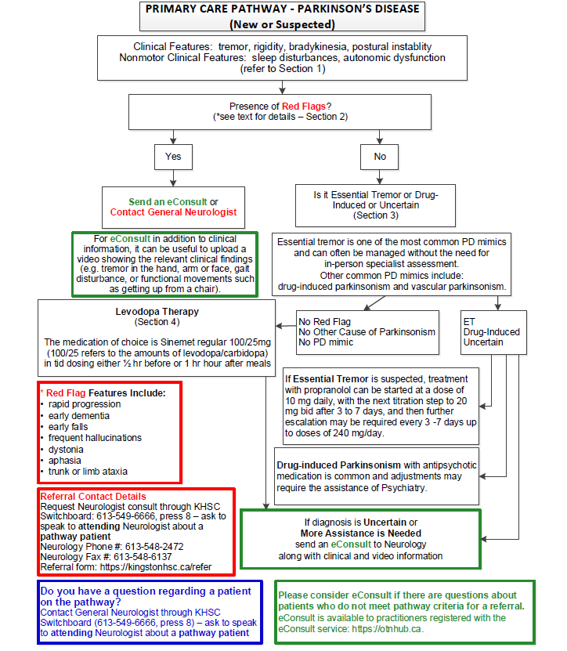

# **Appendix A – Expanded Detail**

## **Section 1 – Parkinson’s Disease Clinical Features Useful for Diagnosis**

***Tremor*** Present at rest at ~3-4 Hz, usually one side more than the other. Observed as patient rests hands in his or her lap; often described as pill-rolling in quality; must be distinguished from postural tremor (as limb is held against gravity) or kinetic tremor (occurs with movements)

***Rigidity*** The physician feels resistance as he or she places a finger within the patient’s antecubital fossa and repeatedly flexes and extends the patient’s arm at the elbow; resistance can be cogwheel rigidity (catching and releasing) or lead-pipe rigidity (continuously rigid); rigidity must be distinguished from spasticity, which shows increased tone when the limb is moved quickly vs more relaxed tone when the limb is moved slowly; rigidity also can be tested at wrist supination or pronation.

***Bradykinesia*** Difficulty with rapidly and sequentially tapping the fingers of one hand and then the other on a table top; difficulty tapping the heel rapidly; difficulty twiddling or circling the hands rapidly around each other in front of the body; reduced arm swing on affected side during ambulation. Often reduced facial expression (“masked facies”) during conversation.

***Postural instability*** Small, shuffling steps may be observed, with difficulty initiating ambulation; patients may have a festinating gait (involuntary acceleration of gait); heel-to-toe ambulation is impaired; arms often are stationary; posture often is stooped; patients may have difficulty turning and have poor balance.

***Other signs of PD***can include difficulty rolling over in bed, difficulty opening jars, micrographia, REM sleep behavior disorder, gastroparesis, constipation, sialorrhea, erectile dysfunction, insomnia, hyper- or hypohidrosis.

***Note about ancillary tests:*** The diagnosis of PD in primary practice doesn’t require CT scan, MRI scan, or EEG. PD is a clinical diagnosis.

***Further information for physicians:*** <https://www.parkinsonclinicalguidelines.ca/guideline/>

## 

## **Section 2 – Red Flags**

***Rapid progression*** Patients who rapidly deteriorate in mobility and need to use a wheelchair within a few years may have other diseases such as multiple system atrophy, or progressive supranuclear palsy (PSP), or other neurological disorders.

***Early dementia*** Normal pressure hydrocephalus (NPH) can present with gait disturbance, cognitive impairment and urinary incontinence. Dementia with Lewy bodies (DLB) can present with sometimes rapid cognitive fluctuation and parkinsonism.

***Early falls*** Cerebellar disorders, NPH, PSP, myelopathies and some forms of peripheral neuropathy can present with early falls.

***Frequent hallucinations*** Consider DLB, or medication side-effects. Also, causes of delirium such as stroke, liver disease, renal disease, vitamin B12 deficiency and electrolyte abnormalities can also give rise to hallucination and parkinsonism.

***Dystonia*** Dystonia and parkinsonism can occur in Wilson’s disease, Huntington’s chorea, and spinocerebellar ataxias. Medications can also cause dystonia and parkinsonism, e.g. prochlorperazine.

***Aphasia*** Aphasia can be a feature of many neurological disorders which sometimes also have parkinsonian features. This includes stroke, chronic neurodegenerative disorders such as Alzheimer’s disease, frontotemporal dementia, and primary progressive aphasia.

***Trunk or limb ataxia*** Parkinsonism and ataxia can occur in conditions such as spinocerebellar ataxia, Fragile X-associated tremor ataxia syndrome, ataxia-telangiectasia and other rare genetic causes of ataxia.

***What to do:*** Send an **eConsult** or contact the General Neurologist on call through the KHSC telephone operator. For **eConsult** in addition to clinical information, it can be useful to upload a video showing the relevant clinical findings such as tremor in the hand, arm or face, gait disturbance, or functional movements such as getting up from a chair.

## **Section 3 – Is it Essential Tremor, or Drug-Induced?**

|  |  |
| --- | --- |
| **Essential Tremor** | **Parkinson’s Disease** |
| Tremor present with holding objects or performing tasks | Tremor present at rest |
| Head/voice tremor | Chin tremor |
| Bilateral onset of tremor, usually hands | Unilateral onset or tremor/bradykinesia |
| EtOH responsive in some patients (1-2 drinks) | EtOH unresponsive |
| No cogwheel rigidity | Cogwheel rigidity |
| Writing is large and shaky | Small handwriting (micrographia) |
| Tremor better with walking | Tremor emerges with walking with reduced arm swing, stooped and shuffling gait |
| Positive family history | Often, no clear family history |

*Essential tremor and PD*

ET and PD can coexist but usually the diagnosis of one condition will precede the diagnosis of the other. For example, many patients may show signs of ET and then several years later may also show bradykinesia, increased limb tone, and postural instability.

Patients who show features of ET and PD at first presentation can be difficult to diagnose and if in doubt then specialist advice through **eConsult** should be sought.

Some patients will require medication for both conditions. For these cases the advice of a specialist should be sought and can be obtained quickly through an **eConsult**.

*Drug-induced parkinsonism*

Drugs that are well known to cause parkinsonism include many antipsychotic medications such as risperidone, haloperidol, olanzapine, pimozide, metoclopramide, and aripiprazole. Assistance from Psychiatry is recommended if the patient needs to have the dose adjusted or a medication change. Often, quetiapine or clozapine can be substituted with the guidance of a Psychiatrist.

## **Section 4 – Levodopa Therapy**

*Initiating levodopa therapy*

Levodopa therapy can be initiated with Sinemet regular 100/25 (yellow tablet) at 0.5 tablets tid for one week and then increased to 1 tablet tid for the second week. A four hour dose interval initially is reasonable as longer dose intervals may result in end-of-dose wearing-off effects.

**If the patient is doing well on 1 tablet tid then the medication dose can be maintained**.

Some patients may require higher doses:

|  |  |  |  |
| --- | --- | --- | --- |
| **Week** | **Breakfast** | **Lunch** | **Supper** |
| 1 | 0.5 tab | 0.5 | 0.5 |
| 2 | 1 | 1 | 1 |
| 3 | 1.5 | 1.5 | 1.5 |
| 4 | 2 | 2 | 2 |
| 5+ | If patient is doing well then maintain current dose. Some patients may benefit with an additional fourth dose of 0.5 to 2 tablets in the evening. | | |

*\*Only increase dose if needed. Many patients will do well on small doses for prolonged periods of time.*

Ideally, Sinemet should be taken on an empty stomach to ensure that levodopa can be optimally absorbed. Sinemet should be taken either a half hour before meals or an hour afterwards.

Sometimes the time interval between medication doses can alter efficacy. For example, it may be necessary to shorten the interval between 2 or 3 doses in the day if meal times are spread out too far.

*Side effects*

Some patients may experience nausea with Sinemet. In this case, a small non-protein-rich snack can be taken with Sinemet. Protein competes with levodopa for absorption and should be avoided when taking Sinemet. Domperidone 10 mg a half hour before taking Sinemet and not exceeding 30 mg daily can also be helpful. Domperidone can be associated with prolongation of the QT interval so it is important to assess the patient’s ECG before and after starting it. Other initial side-effects at starting doses of Sinemet that may be experienced include: fatigue, orthostatic hypotension and dizziness, and dry mouth.

*Low or declining efficacy*

For some patients diagnosed with PD, Sinemet may not seem to have any or only a mild effect on symptoms. In this case, it’s reasonable to question the PD diagnosis and seek specialist advice through **eConsult**.

Patients may eventually show a declining response to Sinemet. Some of the more common reasons for this include: underlying infections (e.g. UTI, pneumonia), changes in dietary habits (e.g. taking Sinemet with food), new medications with extrapyramidal side-effects (e.g. some antipsychotic medications), disease progression, and misdiagnosis. If the response to Sinemet is declining, it is prudent to use **eConsult** to receive rapid specialist advice (typically within 48 hours).

*After the first 4 weeks of levodopa therapy*

Most patients can be managed for several months to years with levodopa therapy before specialist advice is needed to adjust dosing schedules or introduce new medications. Patients’ response to levodopa therapy can evolve over time and can be highly variable. After prolonged use of levodopa, dyskinesias and motor symptom fluctuations can develop. If the response to levodopa therapy is suboptimal from either the patient or family physician’s perspective then an **eConsult** is recommended. In advanced cases other treatment modalities including the Duodopa pump and deep brain stimulation may be considered by the specialist.

# **Appendix B – Patient Information**

*Please note: This information is intended to be given to the patient, either as a handout or in the form of a conversation with their primary care provider.*

**What is “Parkinson’s Disease”?**

Parkinson’s Disease is a “neurodegenerative “condition that affects the brain. Although it can cause many symptoms, the most common are tremors, slowness of movement and stiffness of the muscles.

Other symptoms people may notice include a soft voice, small handwriting, difficulty getting out of chairs, a change in their bowel habits and vivid dreams.

Not everyone develops all the symptoms, and no two people find their conditions to be identical.

The symptoms of Parkinson’s Disease worsen slowly over time. With treatment, many of the symptoms can be managed sufficiently to allow people to live productive, quality lives.

For more information, please refer to the following information at The Parkinson’s Canada website.

<https://www.parkinson.ca/about-parkinsons/understanding-parkinsons/>

If you would like to order the free book “Parkinson’s Disease An Introductory Guide” you can do so at the following website.

<https://www.parkinson.ca/gated/parkinsons-disease-an-introductory-guide/>

**How will my doctor follow my condition?**

Your doctor will be interested in following several aspects of your condition including your balance, hand coordination, mood, and, of course, response to medications. Typically, early Parkinson’s Disease responds well to medications and worsens slowly. In this regard, your doctor will likely need to see you on a yearly basis

**You are enrolled on Parkinson’s Disease primary care pathway. What does this mean?**

The Parkinson’s Disease primary care pathway is tool created by Neurologists, Family Physicians and other patient care experts at the Kingston Health Science Centre. It is designed to help your primary care provider assess the accuracy of your diagnosis and to start the correct plan of investigations and treatment.

**Additional resources**

***Further information for patients:***

<https://www.parkinson.ca/about-parkinsons/>

***Local PD resources:***[Parkinson Canada - Kingston Chapter Support Groups](https://www.southeasthealthline.ca/displayService.aspx?id=73448)  
[VON Greater Kingston - SMART (Seniors Maintaining Active Roles Together) - Group Exercise Program - Parkinson's / Multiple Sclerosis](https://www.southeasthealthline.ca/displayService.aspx?id=185500)

# **Appendix C – Endnotes**

1. David Grimes et al. Canadian Guideline for Parkinson Disease. CMAJ 2019 September 9;191:E989-1004. doi: 10.1503/cmaj.181504
2. Postuma RB, Berg D, Stern M, Poewe W, Olanow CW, Oertel W, Obeso J, Marek K, Litvan I, Lang AE, Halliday G, Goetz CG, Gasser T, Dubois B, Chan P, Bloem BR, Adler CH, Deuschl G. MDS clinical diagnostic criteria for Parkinson's disease. Mov Disord. 2015 Oct;30(12):1591-601. doi: 10.1002/mds.26424.
3. Arjun Tarakad, Joseph Jankovic. Diagnosis and Management of Parkinson’s Disease. Semin Neurol 2017; 37(02): 118-126.
4. Halli-Tierney AD, Luker J, Carroll DG. Parkinson Disease. Am Fam Physician. 2020 Dec 1;102(11):679-691.
5. Shobha S. Rao, Laura A. Hofmann, Amer Shakil. Parkinson’s Disease: Diagnosis and Treatment. Am Fam Physician. 2006 Dec 15;74(12):2046-2054.
6. Stephen G. Reich, Joseph M. Savitt. Parkinson’s Disease. Med Clin North Am. 2019 Mar;103(2):337-350.
7. Enhanced Primary Care Pathway: Parkinson’s Disease, Department of Clinical Neurosciences, The University of Calgary.
8. Joseph Jankovic. Distinguishing Essential Tremor From Parkinson’s Disease. Practical Neurology. Nov/Dec 2012, p.36-38.
9. Thenganatt MA, Louis ED. Distinguishing essential tremor from Parkinson's disease: bedside tests and laboratory evaluations. Expert Rev Neurother. 2012;12(6):687-696.