All body fluids, including blood, along with the soiled/dirty cleaning equipment used to clean any mess must be treated as infectious and handled cautiously. Only knowledgeable individuals should perform the clean-up procedure.

Before beginning the clean-up procedure, restrict access to the affected area and do not leave the contaminated area unattended. A hazard remains until the entire contaminated area and the soiled cleaning equipment have been disposed of safely.

**The basic principles of blood and body fluid/substance spills management are:**

* 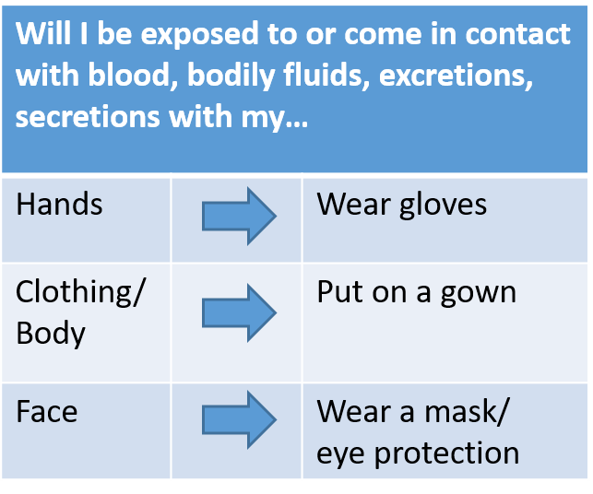Standard precautions apply, including use of personal protective equipment (PPE), as applicable (e.g., gloves for potential transmission to hands, or gown for transmission to skin or clothing).
* Blood, bodily fluids should be cleaned up before the area is cleaned/disinfected.
* Generation of splash/spray from spilled material should be avoided, clean with caution.

**Spill Considerations:**

* Type (sputum, vomit, feces, urine, blood)
* Size (large or small)
* Surface spill is on (hard, soft, absorbent surface, etc).
* Location (high traffic area)

**Equipment Required:**

* Standard Cleaning Equipment (e.g., mop & bucket, cleaning/disinfection agents, paper towel/rags/cloths, garbage, garbage bags)
* Absorbent disposable towels/cloths/rags, or paper towel
* Scoop (for feces or vomit)
* Personal Protective Equipment (e.g., gloves, gown, mask, eye protection) based on risk of contamination

**Precautions for Cleaning and Disinfecting**

|  |
| --- |
| **Mixing a 1:10 Bleach Solution** |
| 100mL bleach: 900mL water  (1 cup of bleach: 9 cups of water)  Contact time on surface is 10 minutes, solution good for 24/hrs |

* Bleach is corrosive and may damage colored fabrics and corrode some surfaces unless rinsed off.
* Staff must wear PPE when handling/mixing bleach
* Bleach should only be used in well-ventilated areas and care should be taken to avoid exposure to skin, eyes and mucous membranes.
* Mix bleach before use, dispose of after use or within

24/hrs.

**Cement and Hard Surfaces**

1. Wear appropriate personal protective equipment, such as disposable gloves when

cleaning up a spill. Torn gloves should not be used, and avoid tearing your gloves on equipment or sharp objects. If the possibility of splashing exists, protective eyewear and a gown should be worn. Eye glasses are not considered to be protective eyewear. Use additional personal protective equipment (PPE), as needed, to protect personal clothing, skin, lips, and eyes.

1. Restrict activity around the spill until the area has been cleaned, disinfected and completely dry. Carefully dispose of any broken glass or sharps into a puncture-proof container. If available, disposal of sharps into an approved sharps container for biomedical waste is preferred. Care must be taken to avoid splash/spray during the cleanup process.
2. Soak up blood and body fluids with absorbent material (e.g., paper towels or other disposable cloths). Mops are not recommended because they are difficult to clean and there may be possible splash or spray. Disinfectants cannot work properly if the surface has blood or other bodily fluids on it.
3. Discard the paper towel or disposable cloths soaked with the blood, vomit, feces or fluid in a plastic-lined garbage bin. If a scoop was used ensure it is rinsed, cleaned and disinfected.
4. Flood the affected area generously with a pre-made bleach solution (1 part household (5.25%) bleach to 9 parts water) and ensure the surface remains wet a minimum of 10 minutes. Ventilate the room well when using a bleach solution. Make sure it is not mixed with other cleaning agents.
5. Blot up the bleach solution with fresh paper towels or disposable rags/cloths. Allow the area to dry.
6. Place all used paper towels and rags/cloths in a sturdy, leak-proof garbage bag. If disposable gloves are used, remove and discard the gloves and other PPE at this point. Immediately tie closed and dispose of the plastic bag into the regular trash.
7. After cleaning and disinfecting the area, wash hands thoroughly with soap and water. If the hands are visibly soiled, then soap and water should be used over a hand rub.

**Carpet and Soft Surfaces**

If the spill occurs on a soft surface, do not use a bleach solution as it can cause discoloration. A low-level disinfectant is recommended to clean soft surface. Steam clean upholstery/carpet with an industrial carpet cleaner immediately if possible. If one is not available, arrange for the upholstery/carpet to be cleaned as soon as possible. If upholstery cannot be cleaned, or is super saturated with blood and body fluids, it must be reported to the supervisor or manager. The supervisor or manager will determine if upholstery should be disposed of or replaced.

**References:**

<https://www.albertahealthservices.ca/assets/info/hp/phys/nor/if-hp-phys-moh-nz-school-cleaning-disinfecting.pdf>

<https://www.albertahealthservices.ca/assets/healthinfo/ipc/hi-ipc-blood-body-fluid-spills.pdf>

<https://www.simcoemuskokahealth.org/docs/default-source/jfy-businesses/cleaning_disinfecting_work_surfaces_contaminated_with_blood_and_body_fluid.pdf?sfvrsn=0#:~:text=Clean%20the%20affected%20area%20with,%2C%20Rotavirus%2C%20Feline%20Calicivirus>