**2023**

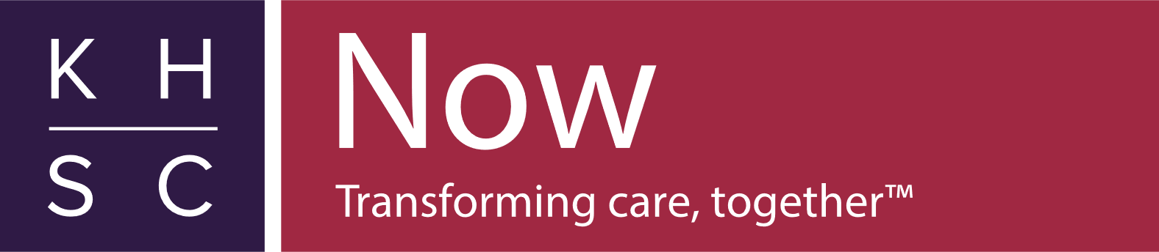**Accessibility Annual Report** A person in a wheelchair on a beautiful day. She is smiling and enjoying the day. She has a red sweater on and a multi colored knit scarf

Contents

Introduction 2

KHSC Who We Are 3

History of The Accessibility Committee 5

Accessibility Committee Meetings 6

Accessible Healthcare Recommendations 6

Establishment Of Accessibility Advisor 7

Work Plan 7

Creation of Inter-hospital Accessibility Working Group 8

Complaint Resolution Process 9

Accessibility Activities 10

2023 Compliance Report 11

Covid 19 12

Next Steps 14

# **Introduction**

Kingston Health Sciences Centre is committed to applying guiding principles and values in everything we do. The principles of partnership, excellence and innovation coupled with the values of compassion, respect and dignity are reflected in our behaviors and actions and in creating an environment that promotes cultural diversity and inclusiveness for everyone who comes to the Kingston Health Sciences Centre. To support these principles and values for those with accessibility issues, KHSC strives for adherence to regulations and standards as outlined in the Accessibility for Ontarians with Disabilities Act, 2005 (AODA).

We hope that this 2023 Annual report will inform you of our intent and our efforts to make KHSC as inclusive and accessible as it can be while acknowledging that barriers continue to exist. When these barriers become known we will work hard to remove them if possible or at the very least to minimize the impact the barrier may have to those who access our care. Although this is the 2023 Annual report it does contain activities and issues that occurred from the beginning of Covid 19. There will be annual reports from now on. For work completed prior to 2019 please see the appendix to our current five-year plan.

# **KHSC Who We Are**

Kingston Health Sciences Centre (KHSC) is southeastern Ontario’s complex, acute and specialty care, research and teaching hospital. Consisting of the Hotel Dieu site, Kingston General site, our satellite sites as well as the Cancer Centre of Southeastern Ontario and our research institute, we care for more than 500,000 patients and their families from across our region.

As one of the region’s largest employers, we are home to nearly 6,000 staff, more than 2,000 health-care learners and hundreds of volunteers who are committed to partnering with patients and families to ensure that we continually provide high quality, compassionate care. Fully affiliated with Queen’s University, we are ranked as one of Canada’s top research hospitals.

As a teaching hospital, we attract some of the nation’s brightest learners to pursue their health care education, which helps to create the capacity to provide highly specialized services close to home. We train thousands of students every year and are home to hundreds of researchers whose curiosity drives them to make ground-breaking advancements in health care.

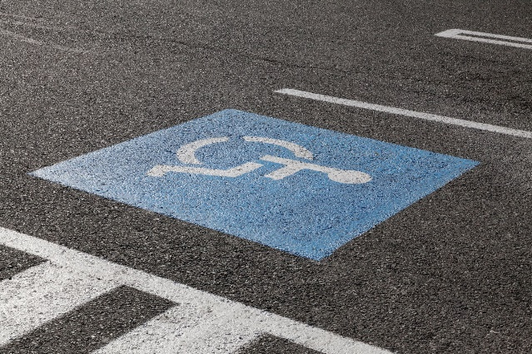

**About our KGH site**

Our KGH site serves as the Regional Referral Centre for cardiac, stroke, renal, trauma, neurosurgery, pediatrics, neo-natal, high-risk obstetrics, acute inpatient mental health, and cancer care.

**About our HDH site**

Our HDH site offers specialized outpatient programs such as pediatrics, medicine, ophthalmology, cardiology, urology, dermatology, gastroenterology, surgery, mental health, oncology and urgent care.

## 

## **History of The Accessibility Committee**

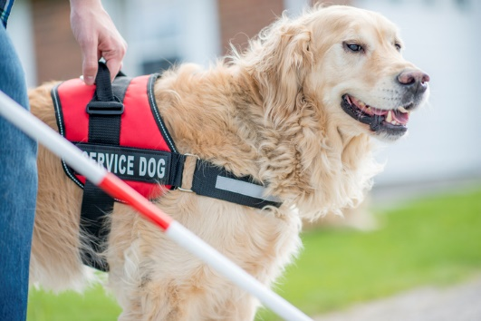

Prior to becoming the Kingston Health Sciences Centre Kingston General Hospital and The Hotel Dieu Hospital were separate corporations and as such had their own respective accessibility committees. Much work was completed by both committees to investigate, review and eliminate where possible, barriers for those with disabilities at both sites. The historical work by both committees can be found in the appendixes of the 2020 “Aim for Access” Five Year Plan. On April 1, 2017, Kingston General Hospital and Hotel Dieu Hospital became the Kingston Health Sciences Centre under one corporation consisting of two sites. Shortly thereafter work began to merge the two Accessibility Committees into one with meetings alternating between the two sites. Accessibility policies differed at both sites, so a group was formed to review, refine and combine the policies ensuring consistent practice across all of our sites. A new combined five-year plan was also developed and approved by the Accessibility Committee for the new KHSC.

**Accessibility Committee Meetings**



Accessibility Committee meetings are held quarterly at the call of the Chair. The committee is made up of interdisciplinary staff from across the hospital as well as members from the community that have either a disability or have a lived experience with a family member who has a disability. Since the beginning of Covid the committee has met virtually.

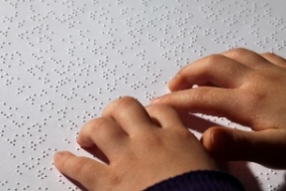

# 

# **Accessible Healthcare Recommendations**

In 2022 the Development of Health Care Standards – Final Recommendations Report was released. The report contains 20 recommendations for the health care sector. Eleven of the standards require action from the Provincial Government, one of the recommendations cannot be acted on by hospitals until the Provincial Government puts the recommendation in place. The remaining eight recommendations can be acted on by hospitals. Although these are only recommendations and not legislated yet, KHSC made the decision to work on implementing the eight recommendations because it was the right thing to do for all who enter and use of facilities and services

# **Establishment Of Accessibility Advisor**

Prior to the final recommendations being released it was acknowledged that if the recommendation were to move ahead, KHSC would have to have someone who could lead the organization in implementing the recommendations. To that end a part-time Accessibility Advisor role was developed and posted with the position becoming active in May 2022. When the final Recommendations were released, they had added a recommendation for hospitals to have someone to take the lead for accessibility in hospitals. It was nice to know that KHSC was six months ahead of the curve in this regard.

The current position is for two days per week.

## 

## **Work Plan**

Soon after the creation of the Accessibility Advisor position a work plan was developed to help guide the process of implementing the 20 Accessible Health Care recommendations. The plan outlines the recommendations, objectives, MRP and department involvement, desired outcomes, timelines, progress notes and comments

The first recommendation was completed with the filling of the Accessibility Advisor position. Work on the remaining seven recommendations is ongoing.

# **Creation of Inter-hospital Accessibility Working Group**

The Accessibility Advisor reached out to other hospitals in our area to create an Inter Hospital Accessibility Working Group. The purpose of this group is to provide peer support by exchanging ideas and experiences involving accessibility and to share policy and procedure with the aim of working toward common practice across the hospitals so that the patient and family experience is the same regardless of the hospital that the person visits. The group includes members from Kingston Health Sciences Centre, Brockville General Hospital, Perth and Smith Falls District Hospital, Providence Care Hospital, Lennox and Addington County General Hospital and Quinte Health.

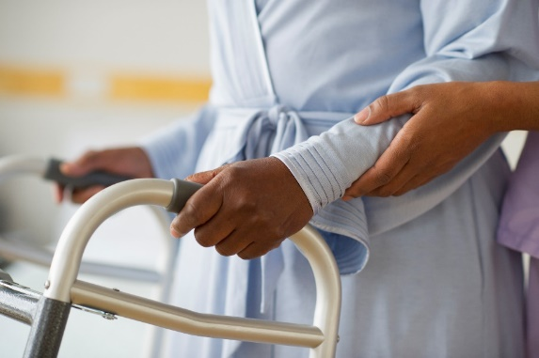

# **Complaint Resolution Process**

Although complaints about accessibility are few, each complaint we do receive is fully investigated with the goal of removing the barrier, if possible or providing an acceptable accommodation to suit the need. Some of the issues brought forward and reviewed by the Accessibility Committee are listed below:

-Service animals

-Accessible change rooms at HDH radiology

-Dimly lit areas of the hospital

-Access bus drop off point

-Electromagnetic Sensitivity

-Visibility of stairwells

-PDF accessibility

-Covid Access issues

-Request for Braille translation

-The need for transparent masks

-Lack of patient call bells in Johnson 6 washrooms

-Challenges in the Emergency department for children with Autism

Complaints and suggestions for improvement can be addressed to the Patient Relations department [patientrelations@kingstonhsc.ca](mailto:patientrelations@kingstonhsc.ca) or by sending an email to [accessibility@kingstonhsc.ca](mailto:accessibility@kingstonhsc.ca)

# 

# **Accessibility Activities**

Over the last few years many accessibility projects and activities have occurred. Some of the activities are listed below:

-Installation of a stair lift in the Murray Building

-More accessible parking spaces created for the Cancer Clinic

-Large button phones installed in the front lobbies

-LED lighting installed throughout HDH for better lighting

-A student project was completed for Accessibility in the Low Vision clinic at HDH.

-The external and internal website were upgraded to AA AODA & WCAG 2.0 standards and specs

- An Accessibility Advisor position was created.

-Positions were created to ensure that someone was available to provide assistance and direction in our main lobbies.

-An Accessibility subcommittee was formed to review the accessibility needs of the KGH Redevelopment Project.

-Translation Services entered a contract with Voyce to provide translations services, including sign language, that can be accessed from computers and mobile devices.

-An accessibility working group was created to review accessibility needs within the Lumeo project and to review the development of a new Patient Portal. Devices that will be used by Lumeo were also reviewed from an accessibility perspective. This group continues to meet.

-An Accessibility Working Group was established with the Accessibility leads in the surrounding area hospitals to ensure consistent accessibility policy across the hospitals and to review issues and solutions. This group continues to meet monthly.

-Signage upgrades have occurred through the Planning Department at both hospital sites in various areas with involvement and review of the Accessibility Advisor. Some reception desks have also been replaced or improved at both sites.

-Transparent masks were provided to departments requiring them to assist those of the deaf community who required them to be able to communicate.

-Patient call alarms were installed in the Johnson 6 washrooms

-Pocket Talkers purchased and distributed where required.

-An Accessibility Audit was conducted in 2020. Result of the audit were positive with no orders or recommendations given.

# **2023 Compliance Report**

The 2023 Compliance Report was completed in December 2023 and was submitted and accepted indicating compliance to the AODA by KHSC

# **Elderly woman receiving an needle from a healthcare worker**

# **Covid 19**

With Covid 19 hopefully in the rear-view mirror we are happy to say that our Accessibility Committee did not miss any meetings and seamlessly switched over to virtual meetings which were, in most respects, more accessible than meeting in person. Covid put a huge strain on all of us but for those with disabilities tremendous challenges were added to that strain. Familiar pathways to care changed sometimes daily. Everchanging signage and instructions complicated things even more. Familiar waiting rooms were reconfigured, and plexiglass was everywhere impeding good communication. To try to hear and answer multiple screening questions through a mask and plexiglass was a challenge but for those with a hearing, speech or cognitive disability it was horrendous. KHSC Leadership and staff are to be commended for their response to Covid 19 and to their willingness to adapt to the needs of the patients and their families. When accessibility issues arose, there was an eagerness to respond. Some examples include; when clear Plexiglas dividers were used to separate line ups, hazard tape was applied to aid those with vision loss. When it was hard to hear through plexiglass and masks, electronic amplifiers were deployed and installed. Font size was increased on all temporary signage. Pictograms were used where possible and high contrast floor signage was applied to help direct people. When long lineups occurred, staff were deployed to canvas the lineup for those that were infirm or had accessibility issues. These individuals were moved to the front of the line. Virtual care was also deployed for those who could use it. When changes had to be made, notices of the changes went out on all our social media platforms to try and communicate the change as broadly and in as many forms as possible.

We hope there will never be another pandemic, but of course there will be one. From the lessons learned from Covid 19, KHSC is well prepared for the next event.

# **Next Steps**

# Well, where do we go from here? We received the final report on the state of accessibility in Ontario in late December 2023. The report urged the government to act swiftly on the recommendations. The target of 2025 for Ontario to be fully accessible is less than a year away. It is safe to say that the target will not be met however we are committed at KHSC to do all we can, within our power to do so, to make healthcare more accessible to all, including those with disabilities. Over the next year our focus will be to develop a new five-year plan as our current plan expires at the end of 2024. Work will also continue to develop and approve new policies on assistive devices and the development of a process to ensure individualized emergency plans are created for those requiring such a plan. Application was made for students again this year with two projects in mind. One includes the inventory of all assistive devices and how they are deployed throughout the hospital. The other will have a focus on how to better educate our staff on accessibility issues and how to create a culture of inclusion of those with accessible needs in decision making.

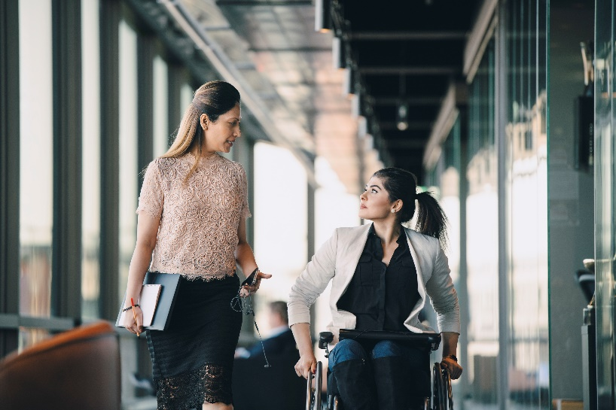

Nothing about us without us!

# 