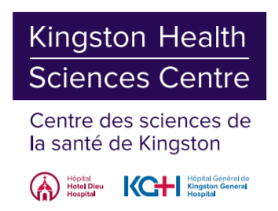

**Emergency Psychiatric Assessment, Treatment & Health (EmPATH) Clinic - Patient Information Sheet**

Adult Mental Health Program (Johnson 5)

Kingston Health Sciences Centre

Hotel Dieu Hospital (HDH) Site

166 Brock St, Kingston, ON K7L 5G2

You have been referred to the Adult Mental Health Program’s EmPATH Clinic at the Hotel Dieu Hospital site of the Kingston Health Sciences Centre.

You will receive a phone call from a nurse, who will complete a telephone intake with you – your call display will appear as HDH-KHSC. Our goal is to call you within 3 business days; however, we may need to gather some additional information that may further assist us, and therefore contacting you may take a little longer.

Please review the below information so you know what you can expect from this referral:

* We will use the phone numbers listed on your hospital file, which would have been confirmed during your visit to KHSC. We will contact you twice only, and if we do not hear back from you, your file will be closed. After a file is closed, a re-referral will be necessary. Please check your voicemails.
* We receive a high volume of referrals for our EmPATH Clinic therefore, we must be very diligent in assessing urgency. Once we have triaged your referral and completed the telephone nursing intake, you will either be given an appointment, placed on a waitlist for an appointment down the road, or we may redirect your referral to a more appropriate service.
* The EmPATH Clinic is an assessment and brief intervention service. Brief follow-up may be offered, however, there may be no further involvement necessary after the initial assessment. You may be referred to internal services with our multidisciplinary team or to community resources, or you may be referred to your family physician or a walk-in clinic.
* The Adult Mental Health Program offers psychiatric consultation and limited follow-up where necessary, and it is not within our mandate, or capacity, to follow patients for a significant length of time. Our model always anticipates patient care will be resumed by a primary care provider or, in the absence of a family physician, a walk-in clinic or virtual medicine clinic.
* The Adult Mental Health Program at KHSC is only able to see patients that reside in Kingston, Frontenac, or Lennox & Addington areas. Owing to high referral volumes, and limited capacity within our clinic, we are currently unable to make exceptions to our catchment policy. If you reside outside of the KFLA region, your referral will be redirected to the local mental health service in your area of residency, either by our office or by your family doctor. You will be notified of this redirection.