**2024**

**Accessibility Annual Report**

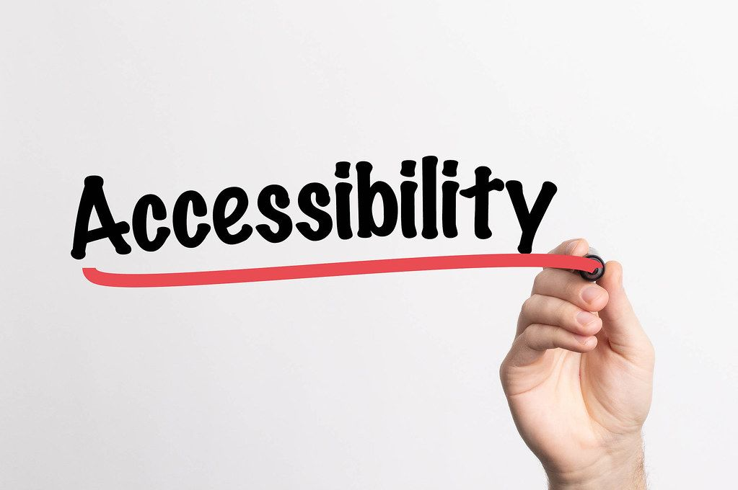

Contents

**Introduction** 2

**KHSC Who We Are** 3

History of The Accessibility Committee 5

**Inter-hospital Accessibility Working Group/ OHCNAP** 7

**Complaint Resolution Process** 8

**Accessibility Activities 2024** 9

10

**Next Steps** 11

# **Introduction**

Kingston Health Sciences Centre is committed to applying guiding principles and values in everything we do. The principles of partnership, excellence and innovation coupled with the values of compassion, respect and dignity are reflected in our behaviors and actions and in creating an environment that promotes cultural diversity and inclusiveness for everyone who comes to the Kingston Health Sciences Centre. To support these principles and values for those with accessibility issues, KHSC strives for adherence to regulations and standards as outlined in the Accessibility for Ontarians with Disabilities Act, 2005 (AODA).

We hope that this 2024 Annual Report will inform you of our intent and our efforts to make KHSC as inclusive and accessible as it can be while acknowledging that barriers continue to exist. When these barriers become known we will work hard to remove them if possible, or at the very least to minimize the impact the barrier may have on those who access our care.

# **KHSC Who We Are**

Kingston Health Sciences Centre (KHSC) is southeastern Ontario’s complex, acute and specialty care, research and teaching hospital. Consisting of the Hotel Dieu site,Kingston General site, our satellite sites as well as the Cancer Centre of Southeastern Ontario and our research institute, we care for more than 500,000 patients and their families from across our region.

As one of the region’s largest employers, we are home to nearly 6,000 staff, more than 2,000 health-care learners and hundreds of volunteers who are committed to partnering with patients and families to ensure that we continually provide high quality, compassionate care. Fully affiliated with Queen’s University, we are ranked as one of Canada’s top research hospitals.

As a teaching hospital, we attract some of the nation’s brightest learners to pursue their health care education with us which helps to create the capacity to provide highly specialized services close to home. We train thousands of students every year and are home to hundreds of researchers whose curiosity drives them to make ground-breaking advancements in health care.

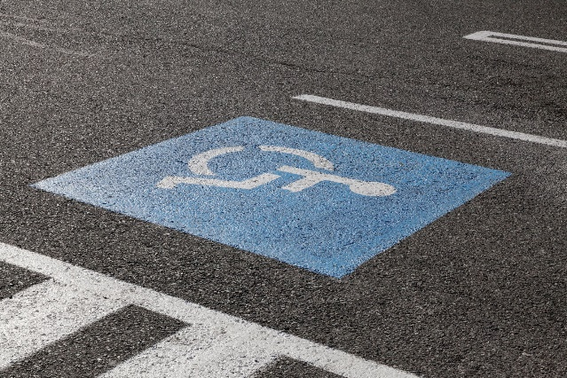

**About our KGH site**

Our KGH site serves as the Regional Referral Centre for cardiac, stroke, renal, trauma, neurosurgery, pediatrics, neo-natal, high-risk obstetrics, acute inpatient mental health, and cancer care.

**About our HDH site**

Our HDH site offers specialized outpatient programs such as pediatrics, medicine, ophthalmology, cardiology, urology, dermatology, gastroenterology, surgery, mental health, oncology and urgent care.

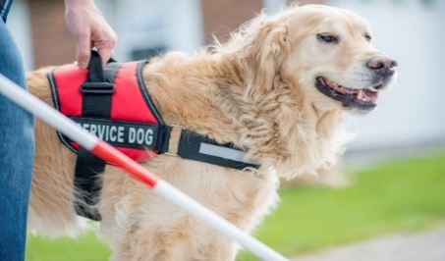

## 

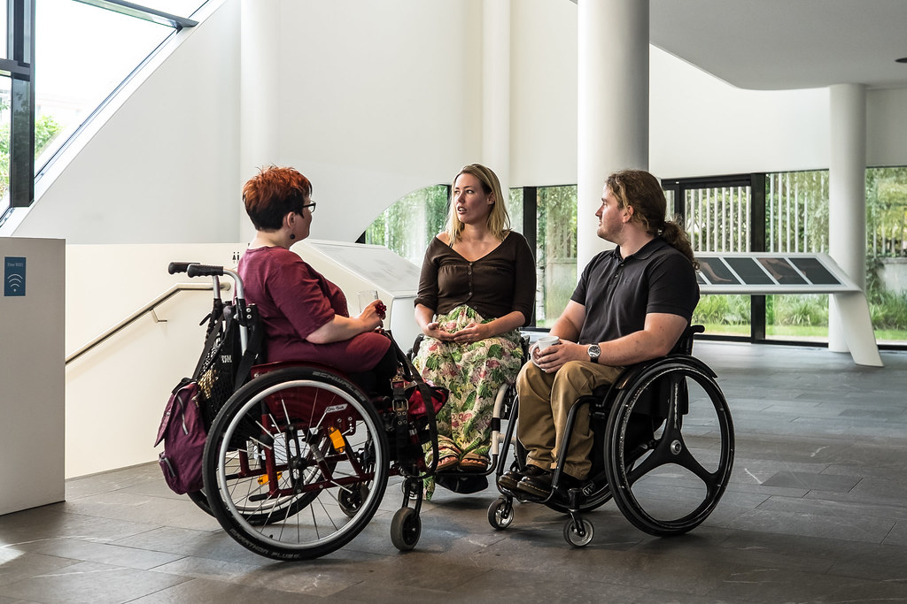

## 

**History of The Accessibility Committee**

Prior to becoming the Kingston Health Sciences Centre, Kingston General Hospital and The Hotel Dieu Hospital were separate corporations and as such had their own respective accessibility committees. Much work was completed by both committees to investigate, review and eliminate where possible, barriers at both sites for those with disabilities. The historical work by both committees can be found in the appendixes of the 2020 “Aim forAccess” Five Year Plan. On April 1, 2017, Kingston General Hospital and Hotel Dieu Hospital became the Kingston Health Sciences Centre under one corporation consisting of two sites. Shortly thereafter, work began to merge the two Accessibility Committees into one with meetings alternating between the two sites. Accessibility policies differed at both sites, so a group was formed to review, refine and combine the policies ensuring consistent practice across all our sites. A new combined five-year plan was also developed and approved by the Accessibility Committee for the new KHSC.

**Accessibility Committee Meetings**



Accessibility Committee meetings are held quarterly at the call of the Chair. The committee is made up of interdisciplinary staff from across the hospital as well as members from the community that have either a disability or a lived experience with a family member who has a disability. Since the beginning of Covid, the committee has met virtually.



# **Inter-hospital Accessibility Working Group/ OHCNAP**

The Inter-Hospital Accessibility group that consisted of the six hospitals in southeastern Ontario disbanded in the fall of 2024 and members were encouraged to join the Ontario Health Care Network of Accessibility Professionals (OHCNAP). This larger group consists of members from over 50 healthcare organizations across Ontario. KHSC’s Accessibility Advisor is currently the chair of this group. The purpose of this group remains the same as the previous group, to provide peer support by exchanging ideas and experiences involving accessibility and to share policies and procedures with the aim of working toward common practice across health care facilities to improve the health care experience of those with disabilities. This group meets four times a year or at the call of the chair.

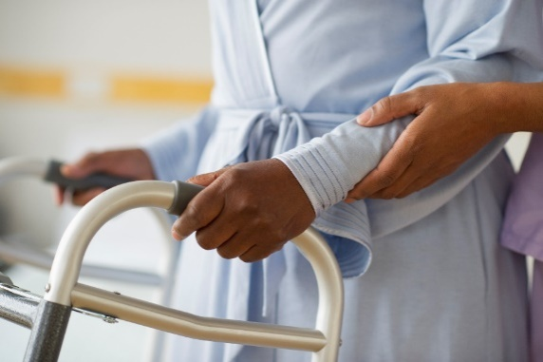

# **Complaint Resolution Process**

Although complaints about accessibility are few, each complaint we receive is fully investigated with the goal of removing the barrier, if possible or providing an acceptable accommodation to suit the need. Some of the issues brought forward and reviewed by the Accessibility Committee are listed below:

-Service and support animals for staff

-Broken parking meters increasing travel distance for accessible parking

- Temporary closure of the Queen’s parking tunnel limiting access to accessible parking

- Voyce and ASL. Lack of in person interpretation

-ICU patient communication barrier

-Smoking adjacent to accessible parking

-Prebooking porters

Complaints and suggestions for improvement can be addressed to the Patient Relations department[patientrelations@kingstonhsc.ca](mailto:patientrelations@kingstonhsc.ca) or by sending an email to [accessibility@kingstonhsc.ca](mailto:accessibility@kingstonhsc.ca)

# **Accessibility Activities2024**

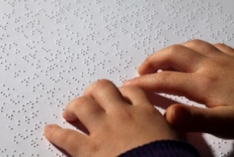

Some of the activities that have occurred during 2024 are listed below:

-Two elevators at the HDH site are being retrofitted to meet current AODA standards.

-The Lumeo Patient Portal was completed with input from members of the Accessibility Committee.

- Planning was initiated to create a barrier free bariatric washroom adjacent to the main lobby at the HDH site.

- Members of the accessibility committee were involved in planning renovations to the HDH main lobby which will incorporate tactile wayfinding in the new flooring.

-The pocket talker distribution center was relocated to the KGH site. This created a much shorter turnaround time to supply patients with a pocket talker when required.

-A new multiyear accessibility plan was created.

-OHCNAP was revitalized with KHSC taking the lead.

-Planning was initiated that will see the trial of contrasting stair nosing being installed at the KGH site in 2025,to aid those with low vision in navigating stairwells.

-A multi-disciplinary group was formed to review and aid a complex patient’s need for a communication device. This was a highly successful initiative that helped a patient with no ability to communicate, to now being able to participate in their care and to communicate with their family.

-Three students from the Queens Occupational Therapy program were involved in two separate projects at KHSC. The first project looked at accessibility devices and their use at KHSC. The second project involved a review of our current website and the educational needs of staff at KHSC. The results of these two projects will be used to help chart the course for future policy and organizational change.

**2023 Compliance Report**

The 2023 Compliance Report was completed in December 2023 and was submitted and accepted indicating compliance to the AODA by KHSC. It is posted on the KHSC website under Accessibility. The next Compliance Report is due in December 2025

# **Next Steps**

# Well, 2024 is over and it is on to 2025! We look forward to finalizing and approving our multi-year plan early in the new year. Our focus in 2025 will be on education and the improved use of social media to promote accessibility activities and to keep people informed of issues at the hospital that might impact accessibility. We will continue to take the lead with accessibility in healthcare through the Ontario Heath Care Network of Accessibility Professionals. Our goal is to make KHSC a center of excellence, setting the example of how a health care organization can improve in providing accessible facilities and services to those who need our care.

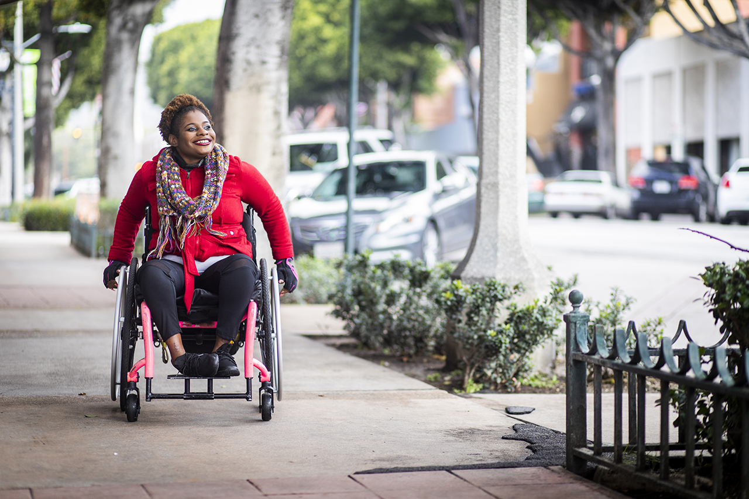

Nothing about us without us!